Administrator@ADMIN-PC /C/Users/Administrator/Documents/NetBeansProjects/Konvers

i_Bilangan (Mia)

$ git log

commit 092aca9895156a40e59964b2b430df7f3dabc459

Merge: bdc9bf7 e0c067b

Author: MiaAmalia <m.amalia@student.uinsgd.ac.id>

Date: Thu Sep 25 13:49:42 2014 +0700

Merge pull request #1 from MiaAmalia/fikri

ditambahin fungsi radio button okta sama heksa

commit e0c067b0a1164b1b928b96bfa70a86c2b08517ed

Author: fikri240794 <fikrianggara@programmer.net>

Date: Thu Sep 25 13:46:14 2014 +0700

ditambahin fungsi radio button okta sama heksa

commit bdc9bf7e99a2a1b5655ac2fcc99fa3c0224f2e6e

Merge: dc3f536 da91865

Author: MiaAmalia <m.amalia@student.uinsgd.ac.id>

Date: Thu Sep 25 13:23:22 2014 +0700

Merge branch 'master' of https://github.com/MiaAmalia/Konversi_Bilangan

commit dc3f5360069edf27d0876477410c392ede452cdb

Author: MiaAmalia <m.amalia@student.uinsgd.ac.id>

Date: Thu Sep 25 13:22:15 2014 +0700

ini versi pertama

commit da918656e1d8ec7983a7fe4a4273319d84193378

Author: MiaAmalia <m.amalia@student.uinsgd.ac.id>

Date: Thu Sep 25 13:19:15 2014 +0700

Initial commit

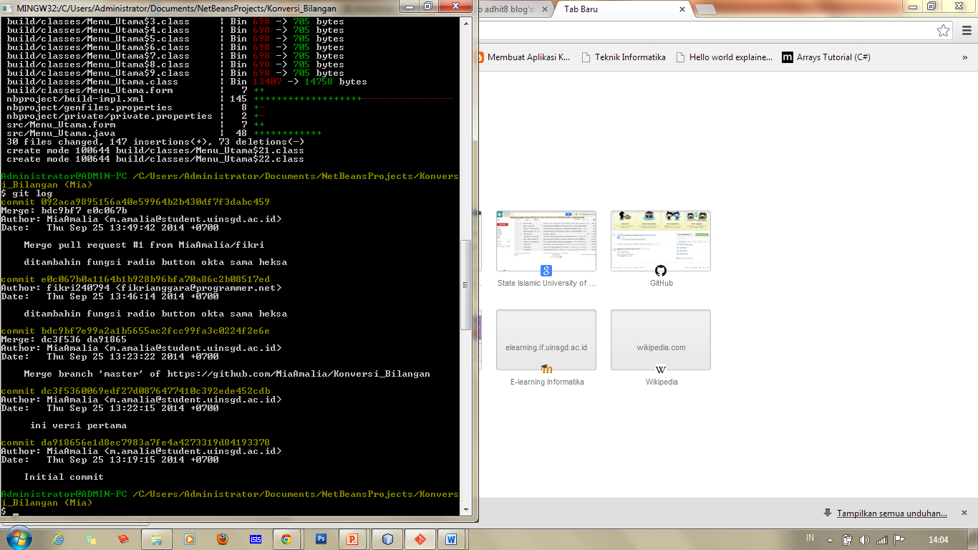

$ git log

commit e6222c4cd8b1d5103b685a6b23e1a8fcd8a8e886

Author: MiaAmalia <m.amalia@student.uinsgd.ac.id>

Date: Sat Sep 27 01:11:27 2014 +0700

resolve conflict again

commit 521560db083271247a7684b54010c0d8aacce0c4

Author: MiaAmalia <m.amalia@student.uinsgd.ac.id>

Date: Sat Sep 27 01:02:36 2014 +0700

Ini buat konversi desimalnya

commit c2f15bdb17fbac1c843edcb1c2e491cb43ad1a9d

Author: MiaAmalia <m.amalia@student.uinsgd.ac.id>

Date: Sat Sep 27 00:27:58 2014 +0700

update konversi biner

commit 1bc111e5fa285f7d0c6ee950ce7c03be6bf1546f

Author: MiaAmalia <m.amalia@student.uinsgd.ac.id>

Date: Sat Sep 27 00:17:09 2014 +0700

setelah resolving conflic

commit 9cdbdd9209c1e19a5b19476ee0a0f5ed2bb04b27

Merge: d73f20d a544a4f

Author: MiaAmalia <m.amalia@student.uinsgd.ac.id>

Date: Sat Sep 27 00:08:50 2014 +0700

resolving conflicts

commit a544a4f70ea71aeee785265b59b8a2e00b1eb421

Merge: 092aca9 8cf1d51

Author: MiaAmalia <m.amalia@student.uinsgd.ac.id>

Date: Fri Sep 26 19:51:38 2014 +0700

Merge pull request #2 from MiaAmalia/fikri

Fikri

commit 8cf1d51add2240e6f5833acbc91d9c13ef70334d

Author: fikri240794 <fikrianggara@programmer.net>

Date: Fri Sep 26 19:36:41 2014 +0700

Mia, ini udah selesai, tolong merge ke master, tinggal yang biner sama desi

commit d73f20d3b247da6bcaef9f1e5a377618570a2588

Author: MiaAmalia <m.amalia@student.uinsgd.ac.id>

Date: Thu Sep 25 14:32:36 2014 +0700

ini baru konversi binernya

commit 346c289160ab347d7be6111d38ed703ed8803c57

Merge: ab88006 092aca9

Author: fikri240794 <fikrianggara@programmer.net>

Date: Thu Sep 25 14:07:09 2014 +0700

